- Similarities and Enlargement

1. Two tanks are similar in shape. The capacity of the tanks are 1,000,000 litres and
512, 000 litres respectively.
(a) Find the height of the smallest tank if the larger is 300cm tall (4 mks)
(b) Calculate the surface area of the larger tank if the smaller tank has a surface area of
1200m² (3 mks)
(c) Estimate the mass of the smaller tank if the mass of the larger one is 800kg (3 mks)
2. Under an enlargement transformation point A(1,-4) is mapped onto A¹(2,5) with scale factor 3. Find the centre of enlargement. (2mks)
3. In the figure below, AB is parallel to DE. Find the value of x and y. (3mks)
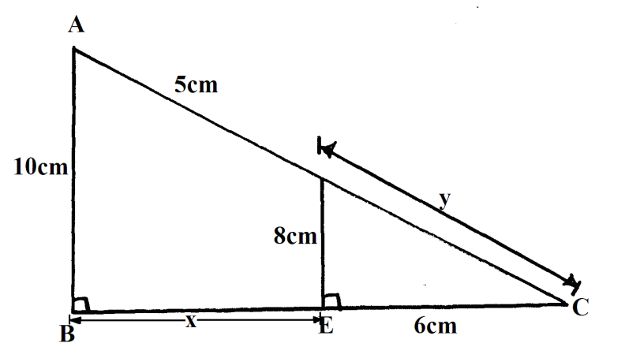
4. Two similar cans have different heights 8cm and the other one 10cm. If the surface area of the larger can is 480cm², find the surface area of the smaller can. (3 marks)
5. The area of triangle ADE is 15cm². Given that BD:BA = 1:3, and DE is parallel to BC. Find the area of triangle ABC in the figure. (3mks)
A
B
C
E
D

6. Triangle ABC has vertices at A(1, 4) B(2, 6) C(2,5). Its image under an enlargement has vertices at A¹(3,2) B¹(5,6) C¹(5,4).
(a) Find the centre and scale factor of the enlargement. (3mks)
(b) Triangle ABC is given a rotation of -90⁰ about the origin to get A¹¹B¹¹C¹¹. write down the coordinates of A¹¹B¹¹C¹¹. (2mks)
(c) A¹¹B¹¹C¹¹ is reflected on the line y + x = 0 to get A¹¹¹B¹¹¹C¹¹¹. Give the coordinates of the image A¹¹¹B¹¹¹C¹¹¹. (2mks)
(d) Find a single matrix that maps A¹¹¹B¹¹¹C¹¹¹ onto ABC. Describe this single transformation. (3mks)
7. Give the inequalities which define the region R
a)
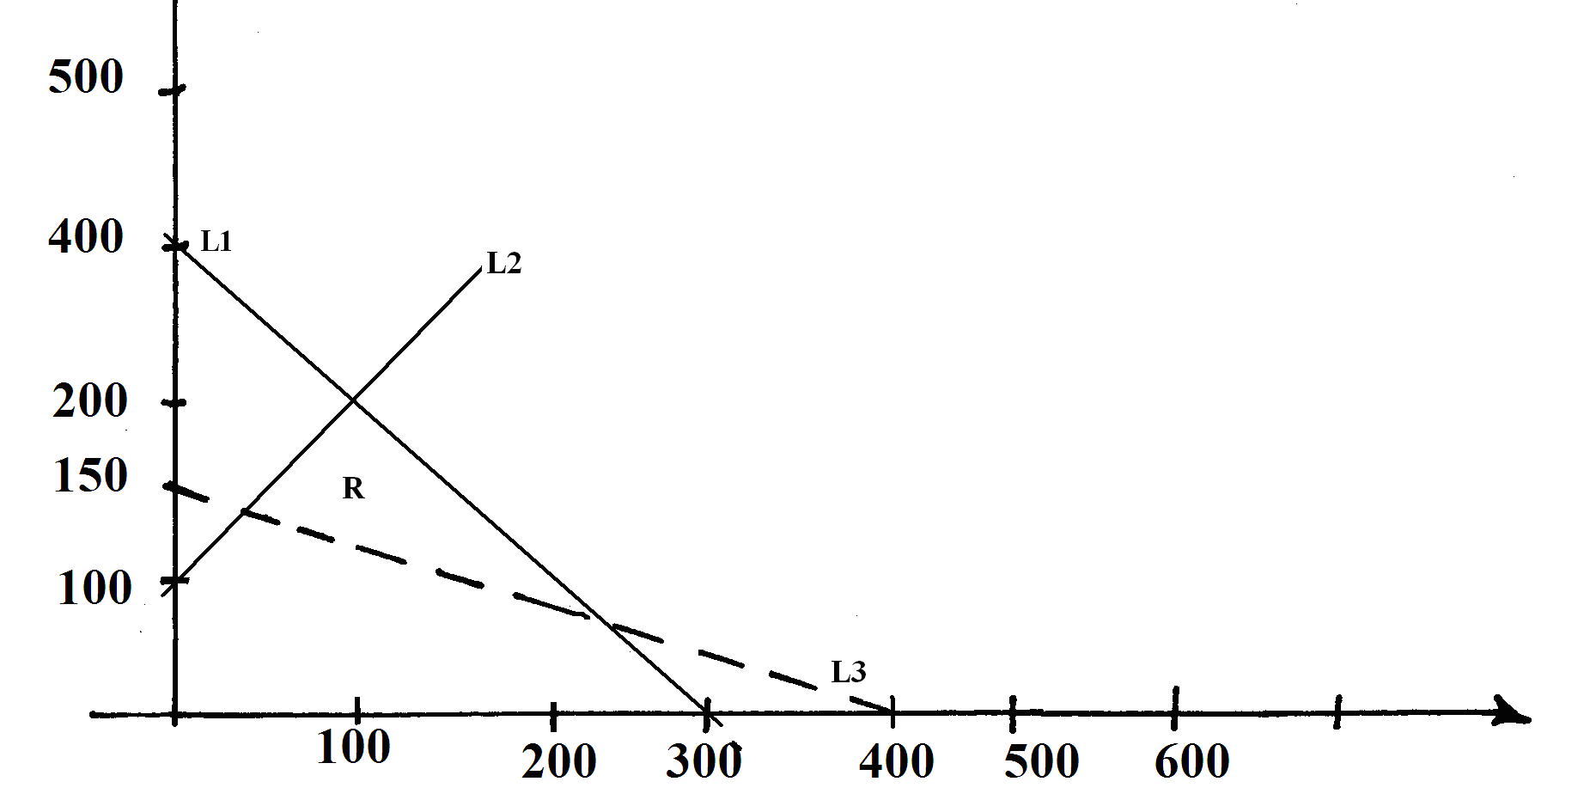 (6mks)
b) Under enlargement with scale factor -3, the point P(3,6) is mapped onto P₁(7,18). Find the centre of this enlargement and the image of the point Q₁(1,1) under the same enlargement (4 mks)
8. The masses of two similar bars of soap are 343g and 1331g. If the surface area of the smaller bar is 196 cm². Calculate the surface are of the larger bar. (3 marks
9. The image of P(0,2) under an enlargement with a scale factor 3 is P¹ (4,6).
Find the co-ordinates of Q

10. A model of a building is made using a scale 1:500.
(a) Find the height of a room (in meteres) in the building which is 5cm long on the model?S***
(b) A room has a floor area of 36m². What is the corresponding area on the floor of the model
(c) A room has a volume of 120m³. What is the corresponding volume of the model in cm³?S***
11. In the triangle ABD, BA is parallel, to CE, given that BA= 9cm, CE = 4cm and AE =3cm,
find the length of DE
4cm
9cm
A
B
C
D
E

12. In the following figure, PR = 12cm, TR = 4cm and ST is parallel to QR. Given that the
area of triangle PQR is 336cm², find the area of quadrilateral QRTS
S
T
R
Q
P

13. Two dogs regarded similar with the length in ratio 4:3:-
(a) If the bigger dog has a tail 64cm long, find the length of the tail of the smaller dog
(b) If the smaller dog requires 810g of meat per day how much meat per day does the bigger
dog require

14. In the figure below, ADE is a triangle and BC is parallel to DE, AB, BD and BC are
A
C
E
D
B
4cm
3cm
4cm, 3cm and 8cm respectively.

Find the length of DE

15. The surface area of two similar bottles are 12cm² and 108cm² respectively. If the larger
one has a volume of 810cm³. Find the volume of the smaller one
16. Given that the area of the trapezium CDEB is 15.6 cm², find the length EA marked X.
C
D
A
E
4cm
x
3cm

